Hockey Sticks or Boomerangs? The Global Warming Debate as an International Controversy
By Bennett Pifer
2006
Abstaract:
“The strongest arguments prove nothing so long as the conclusions are not verified by experience. Experimental science is the queen of sciences and the goal of all speculation.”
-Roger Bacon

Introduction:
Over the course of the last century the average temperature of the earth at any given time has risen one degree. For years we have frivolously burned fossil fuels, expelled harmful gasses into out atmosphere, and cleared forests without any regard for the startling effects occurring now. The question we are now asking ourselves is that it is our fault that the earth is getting hotter? Are we responsible for what is happening to out planet? Scientists and politicians can not seem to agree on the subject, and there is no consensus to exactly what is going to happen in the coming decades.
This is not necessarily a debate concerning opposing political parties, nor an economic battle, more it is a rift in politics that you are either on one side or another. Senators and congressmen from both parties are takings sides and trying to defend them with what they believe is to be the truth. It is a debate that has spread to the farthest corners of the planet and been the center for international controversy for a few years running. Traditionally the Republicans take the conservative approach to global warming, siding with the skeptics on the subject. Much of this is blamed on the support of fossil fuel usage and pro-industry beliefs of the conservatives. They also believe that there is a clear trend between our countries increasing GDP and increase in carbon dioxide levels in the atmosphere. Conservatives fear that if we cut carbon emissions we will be setting the stage for our own economic downfall. Democrats refute most of this, believing most scientists and researchers that say global warming is happening and that we are causing this rise in global average temperature (Glick 2004).
Al Gore has been perhaps the most recognizable face leading the charge against global warming in recent years. To skeptics on global warming, Gore’s film “An Unfortunate Truth” might not be the truth at all, and to some conservative extremists, it might even be a total hoax. Al Gore does however have the power of popularity, and this has made the subject of global warming more popular than ever. We have to understand that this rift in the political world is ultimately being caused by the many different opinions of the best climate research scientists in the world. As a result of their uncertainty, we are almost forced to choose who and what we want to believe. As of now, there are no right answers, foolproof models, or feasible solutions to the current global warming trend. By this time, it is almost safe to say that there is a consensus amongst scientists that over the past 100 years the earth has warmed up about an average of one degree Celsius worldwide. I say almost safe because this is a very touchy issue right now and assuming anything on the subject is taboo. That said, the current issue is not so much whether global warming is occurring, more the following;
- Whether the climate is changing beyond natural variations in the historical temperature record.
- Whether human/industrial activity is responsible for the change and if so, to what extent.
- How large future changes will be.
- What the consequences of climate change will be.

As we will see, the biggest issue at hand is the question over whether human activity, particularly the burning of fossil fuels, is the main cause for the current increase in temperatures. The Earth’s atmosphere acts like layers upon layer of blankets covering our delicate planet. As far as we know, before the burning of fossil fuels the width of this blanket was perfectly balanced with our earth’s ecosystem. Most scientists would agree that after man started burning fossil fuels, this blanket-like covering of carbon dioxide got thicker and thicker, trapping more heat, and thereby causing the planet to heat up. While this seems to make sense, many scientists can not rule out the possibility that these temperature changes could be purely the result of natural climate variability. In this paper, I will analyze several peer reviewed articles that take opposing sides on the global warming issue. I hope to show that there are still convincing arguments on both sides and that the global warming debate is far from over.
Let us begin by analyzing a report given by Dr. Hanson in 1998 to try and clear up some issues in the global warming debate. Dr. Hanson is attempting to provide scientific explanations for the idea of global warming without taking sides and getting into a political debate. He does however write that it is a heated topic, and that the American people are being deprived their rights by not getting to hear the truth from politicians who have elections in mind instead of the best interests of the people.
Hanson begins by summarizing the global warming debate with a simple cartoon-like model. He says that in the seventies he and a few co-workers worked to find the exact effects of C02 in the atmosphere. He concluded that the exact warming since the industrial revolution is about two watts per square meter of the earth’s surface, or about two small Christmas lights per meter squared. This would equate to about the same as the sun increasing in strength by 1%. Hanson goes on to talk about the Charney report, which attempts to explain what would happen to the earth’s climate if global C02 level doubled again. Hanson presents the raw data that proves global average temperature has risen an average of 1 degree over the past century. He writes that this is fact and that it can not be altered by politics or biases, yet in his power point he writes that he is only 99% sure. He does not address this 1% doubt and why it exists. Hanson wonders when people will physically be able to feel that something is changing. The increasing frequency of warmer than average summers has to make some people start to believe in the idea of global warming. He does address the fact that all the assumptions made in his paper are the result of purely uncertain science (Hansen 1998).
Hanson’s main objective here is to try to prove to the world that global worming is happening. He does not attempt to attribute this to human activity, more he just wants us to accept the fact that the earth is warming up and that we need to be aware of this. Even with all of the data that Hanson collects however, he still presents doubt in his own work. This doubt is probably the result of the uncertainties in the data he used when computing his figures.
Therefore, we again have to ask ourselves if we are to blame. Is this the result of our doings, or is this change in climate just something that happens every so often? The time scale that we are seeing this climate shift occur adds further skepticism to the subject. Normally climate shifts, as far as we know, can take up to 100,000 years to complete. Though scientists think that there are cold and warm periods that can last just a few hundred years at a time, this one is taking place over what looks to be just a life time. Though the full effects of global warming will not be known for another 50 years or so, it is clear that they will be drastic, and maybe even catastrophic (Glick 2004).
Dr. Lindzen is one of the most renowned protagonists in the global warming debate. His general stance on the issue is that the science behind the argument isn’t sufficiently accurate to be able to make assumptions on global warming. In one specific article published in August of 2006, he attacks Democrat, Al Gore, for making such statements in his recent film such as ‘the scientific debate is over’, inferring that scientists have agreed that global warming is occurring. As we will see in these writings by renowned scientists, there is still much disagreement on the subject. According to Lindzen, this agreement that Al Gore spoke of in his film is definitely not true (Lindzen 2006).
Dr. Lindzen goes into detail refuting parts of Al Gores movie, specifically the photography that Mr. Gore presents with little or no scientific statements to back it up. Lindzen claims that at first glance during Gore’s movie, it appears the Greenland ice sheet is melting right before out eyes. These short clips usually show large chunks of the ice sheet breaking off and falling into the ocean, making huge wakes and throwing large amounts of water into the air. While these are pleasing to the eye and look like there is reason for alarm, according to Lindzen, events like these is the result of the Greenland Ice sheet actually growing from the interior out. As the ice sheet becomes larger on the inside and sections on the outside begin to hang over the water, they break off. Lindzen also claims that most glaciers that seemed to be getting smaller stopped retreating at about 1970, and since then many have begun to increase in size again (Lindzen 2006).
Lindzen exposes a few of the important documents that have led to numerous assumptions about global warming. Specifically, he outlines the document that led CNN to report that it is unanimous among scientists that global warming is happening and being caused by human activity. The document stated no such thing. Issued by the National Academy of Sciences, the report responded to questions about global warming from White House. The document thoroughly explained that much of the science that they were outlining was very speculative and purely the result of models and unproven testing methods. The document ambiguously claimed that "The changes observed over the last several decades are likely mostly due to human activities, but we cannot rule out that some significant part of these changes is also a reflection of natural variability." CNN's Michelle Mitchell went on to report exactly the opposite of what the document was saying, that it was a "unanimous decision that global warming is real, is getting worse and is due to man. There is no wiggle room" (Lindzen 2006).
We see speculations like these everyday in the media, but for some reason claims made on the subject of global warming, are being taken as fact. That’s not to say that these claims are not truth, but it seems in a way that the public has let their guard down to the often unreliable media. Lindzen sums up his opinion on this idea during an interview with BBC world; “it’s like quackery in medicine,” Lindzen Says, “if somebody says you should take jelly beans for cancer and you say that’s stupid, and he says, well can you suggest something else and you say, no, does that mean you have to go with jelly beans?" (Lindzen 2006) Lindzen is just warning us to keep an open mind on the subject and not to base our own opinions on the claims of others. Lindzen does strongly acknowledge the fact that global warming is occurring but ends his paper with a few closing remarks of advice for the reader:
- First, nonscientists generally do not want to bother with understanding the science. Claims of consensus relieve policy types, environmental advocates, and politicians of any need to do so. Such claims also serve to intimidate the public and even scientists--especially those outside the area of climate dynamics.
- Secondly, given that the question of human attribution largely cannot be resolved, its use in promoting visions of disaster constitutes nothing so much as a bait-and-switch scam. That is an inauspicious beginning to what Mr. Gore claims is not a political issue but a "moral" crusade.
- Lastly, there is a clear attempt to establish truth not by scientific methods but by perpetual repetition. An earlier attempt at this was accompanied by tragedy. Perhaps Marx was right. This time around we may have farce--if we're lucky (Lindzen 2006).

The hockey stick graph is a compilation of ten different published reconstructions of mean temperature changes in the past 1000 years. This graph is highly debated, especially because before 1850 there were no thermometers or temperature measuring devices and therefore, all temperature records before this time had to be entirely reconstructed. These are based on proxy data gathered from sources such as tree rings, ice cores, and even stalactites. With so many uncertainties in this area, we are left with the question of which on of these methods is the most effective representation of the true climate record? One thing is for certain, when overlaid, all of the graphs follow the same general path and show signs of abrupt warming in the atmosphere in the past 100 years. Interpretations of this ‘hockey stick’ like graph vary, of course, the main issue in question is whether human activity is to blame for this drastic increase in temperature.
Dr. Ross McKitrick has done a lot of research on this topic and has concluded that there are some clear signs of bias in the entire presentation of the Hockey Stick graph. He believes that the “international trust in the intergovernmental panel for climate change (IPCC) has been betrayed.” He suggests that this must change in order to make future assessments on the severity and the future effects of global warming. Basically, politics can not be a part of the science, and all presumptions of the topic must be ignored in order to see the threat of global warming as it is today. Mckitrick questions the methodology in which the data was collected and how the results are unsupported by the data. For example, McKitrick suggests that climatological data collected from the rings of trees is subject to high errors and thus infers that they are almost impossible to calculate correctly. This could however just be an attack against the creator of the Hockey stick graph, and leader in tree ring proxy data research (Mckitrick 2005).
Dr. McKitrick begins by describing how the very layout of the document presented to the IPCC was bias to show that global warming might be worse than it actually is. The document shows the Hockey stick graph on one side of the page presented in color while the weather balloon and satellite data from the 20th century presented on the left side are barely addressed in the text; both of which hold important data that is pivotal for proving the science behind global warming. McKitrick argues that this shows clear bias on the part of the IPCC, in this case trying to gain support for the passing of the Kyoto protocol.
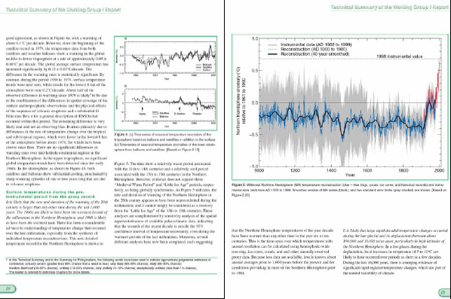
(Previous) The Hockey stick, as shown on the right in full color, with the equally important, yet less visible, satellite and weather balloon data on the left. You can see here that the warming trend as shown by satellites is much less drastic than by surface measurements. Mckitrick 2005

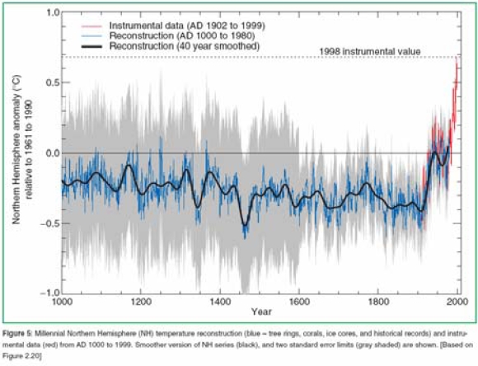
The Hockey Stick Graph.. Note the increase in error margin before 1600. Mckitrick 2005
From my research, in 1995 when there was not yet a Hockey Stick graph, the general consensus among scientists was that there was a medieval warm period that far outweighed the severity of the warming that we are experiencing today. Mckitrick says that this would seemingly make the warming trend of the 20th century just a small fluctuations in a natural cycle. 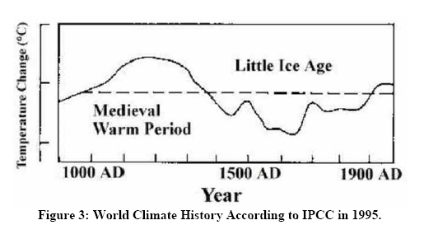
This however was not so. When the University of Michigan’s borehole proxy data was finally released in 1997, only the data from the year 1500 to present was shown, coincidently, as they completely eliminated the data from the medieval warm period, a clear warming trend was evident. That same year the first version of the Mann Hockey Stick graph was released which also seemed to dwarf the medieval warming period. Mann’s graph became the new icon for climate change. The visual image of the hockey stick was frightening to some and began to attract more interest from the public than ever. By this time, as McKitrick writes, because of the hockey stick’s popularity and wide acceptance, refuting the idea of the Hickey Stick graph was practically sac religious in the world of climatology.
McKitrick goes on to discuss in detail the further problems in deriving the Hockey Stick graph, particularly in the data processing measures taken by Mann. We can conclude by the end of the publication that according to McKitrick, the Mann Hockey Stick graph is the result of twisted truth and exaggerated facts. Mckitrick never denies the fact that we are currently experiencing a warming period, more that we are just being fed biased information for all the wrong reasons. He continues to refute the work of Mann, while Mann claims that his work is uneducated and ignorant (Mckitrick 2005).
We will now look at an essay published in 2006 by Michael Mann, a leading scientist in support of Global Warming. In this essay, Mann gives us an up to date version of the facts as he sees them. Mann says that the climate is definitely warming. He does acknowledge natural forcings that cause the climate to warm and cool, but he expresses zero doubt that the warming trend that we are experiencing today is due to anthropogenic forcings. Mann also recognizes the fact that our instrumental records do not go back far enough to make accurate assumptions about the climate we are experiencing today. Therefore, we use proxy data records to try to paint an accurate picture of the climate in previous centuries and millenniums. Particular to the research of Mann, a network of 1232 annually resolved proxy data sets consisting of tree rings, corals and sclerosponge series, ice cores, lake sediments, and speleothems combined with reconstructions of European seasonal surface temperatures back to 1500 CE based on a composite of proxy, historical, and early instrumental data (Mann 2006). 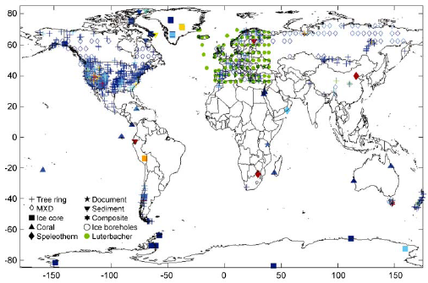A map showing where the proxy data for most of Mann’s work is acquired. Note the lack of data from some areas in the world. This lack of data is a big issue in the climate debate. Mann 2006
Mann goes on to explain how each of the proxy records are acquired and processed to show such graphs such as the hockey stick. We get a good idea of the science here, but also see the enormous room for error within all of the data processing steps and computer models. Mann then addresses the issue of the Medieval Warm Period and the Little Ice age. He writes that in his opinion, these are real events that did happen, but based on where the proxy data was acquired, the severity of the events vary greatly. This means, when displaying a graph for whomever to see, Mann can choose to either make these periods look substantial, or dwarfed compared to today’s warming trend. To my amazement, the caption to the graphs discloses a 95% uncertainty region, expressed as grey area on the map. Mann does point out the fact that is undoubted by all scientists, the sharp increase in temperature since the beginning of the industrial revolution.
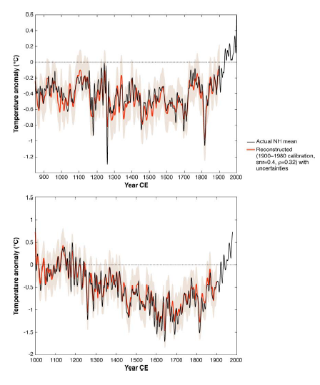Two graphs showing the gradual temperature increase in the last millennium as shown by data acquired from two separate locations. Note the variance in the medieval warm period and the little ice age. Mann 2006
Mann writes that these temperature changes could be greatly attributed to Pacific Decadal Oscillations, today known as El Nino and La Nina, which lasted for extended periods of time. If this is true, as proxy data from the Pacific Ocean confirms this, then according to Mann, this would make these periods unimportant when analyzing climate change on a millennial scale. He continues his discussion on how the location of proxy data changes how the climate record looks on a graph. We can see from the following graph, with which Mann provides us, that various locations and areas hold much different climate records. He states again however, that the part that we are most concerned about is the last 150 years, where regardless of the source, we are seeing a sharp increase in temperature data (Mann 2006).
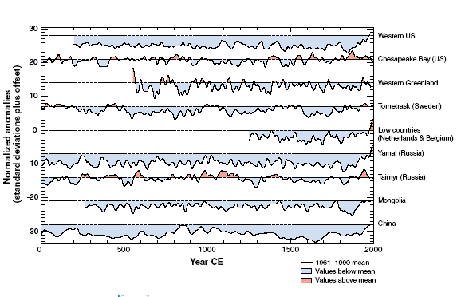
Mann writes that El Nino Southern Oscillation can be attributed to much of the earth’s past variations in climate. Based on proxy data, there are many instances where we see extended periods of warming in the pacific that effect the climate worldwide. In Mann’s work, he attributes the Medieval warm period to an extended period of cooling in the pacific, or a long period of La Nina-like temperatures. The Little Ice age can therefore be traced back to a period of warming, or El Nino. This information was attained by studying proxy information typically associated with pacific oscillations, particularly drought conditions in certain areas of the southern hemisphere. Mann sums up his work by reiterating that the warming trend in the late twentieth century is anomalous in context with the past 1000-2000 years. Also, that large scale atmospheric circulation patterns such as North Atlantic Oscillation and ENSO play an important role in explaining regional patterns of climate change and variability.
Mann leaves us with a few important issues that we will be facing over the decades to come when dealing with global warming. These include; the need for longer and more high quality proxy records from regions where we are currently lacking data, as well as reduce uncertainties in current data. The need for more reliable estimates of long term radiative forcings to better determine that what we are seeing in the past 1000 years is indeed an anomaly to our climate history (Mann 2006).
In my opinion, Mann’s article attempted to be quite non-political in nature and was very informative. There is definite science behind all of his assumptions and he has an open-minded attitude about other opinions. He does address the issues brought up by scientists that challenge his research, and attempts to resolve them with hard facts and data. Mann gives us a very interesting explanation for the medieval warm period and little ice age. We have to somewhat decide for ourselves whether the data from the places that express these periods most conservatively was used to gain support for global warming. If so, was this politically motivated? Mann is often associated with the Democratic Party, as his views on global warming are fairly radical by nature. Mann has been very influential in the fight for recognition of Global Warming by world leaders, as well as in an attempt to gain public support for awareness on the subject.
His work is supported strongly by the IPCC and some parts of “An Inconvenient Truth” were based on his research. So why is there still doubt over Mann’s scientific research? With proof like Mann provides us with, how are there still skeptics about anthropogenic global warming?
Chris Moony sums up this argument fairly well. Chris refers to the global warming skeptics as a “curious species”. He claims that they actually enjoy highlighting small uncertainties in climate science and that their work is absolutely politically motivated by industry and rude of all evil, money. Mooney thinks that the very fact that global warming skeptics are up against the scientists employed by the United States is enough to assume that their work is inaccurate. He does recognize the fact that the skeptics do agree global warming is happening, and that the work of even the best scientists contains errors and inconclusive assumptions. Mooney thinks that come the release of the next IPCC report in 2007, many of the current global warming skeptics might cross over. Even with this however, there will always be doubters that will always side with the “underdog” (Mooney 2005)
Chris brings up a very good point in saying that even if there isn’t enough information to say that global warming is definitely going to get worse, it couldn’t hurt to start preparing for it. Why not try to clean up our air anyway, just for our own good? This is very interesting in that if the skeptics are independently coming up with these ideas, then why aren’t they encouraging precautionary measures? It seems to me that such measures would cost as much as if there was proof of all the aspects of global warming, and that by taking precautionary measures would defeat the ultimately economic purpose of siding against global warming. Chris goes on to quote Kant on his philosophy of the categorical imperative. The categorical imperative states that we should act only as how we would like the rest of the world to universally adopt to their behavior. He says that to the skeptics, this is far from being true. If this was the truth, then the skeptics would surely want politics to be evolved with every scientific decision where some error is present, and also, that with every issue similar to this, political inaction would be accepted even with warnings of such catastrophe. Chris concludes by saying that it is natural for us to want to allow for some possibility that eventually the skeptics might overturn the mainstream view towards the subject. He adds that for some reason in the case of the global warming debate political action is on hold because there is a debate. This is backwards compared to normal, where there is political action, and then there is controversy in response to the action. Mooney ends by saying this; even though there are some skeptical beliefs on the subject and that there is much controversy over the subject, logically action must still be taken soon just to be safe. In sum, it is rational to allow for the remote possibility that global-warming skeptics may someday overturn the mainstream view. But that doesn’t mean we must delay political action while they attempt to do so (Mooney 2005).
For now, at least until the 2007 IPCC report is released, controversy and debate will continue over Global Warming. It seems however, as Mooney said, as long as there is even the slightest error in global warming research, there might always be those who are skeptical about it. We have to keep open minds and at least be aware of these opinions, as far fetched as some of them are. Global warming is obviously not perfect science, but it is something that we obviously need to keep a close eye on for the decades to come. Its important that we recognize that with Global Warming at this time, there aren’t many right or wrong answers. Even with just what we know now, it wouldn’t hurt to start doing something about it. Every little bit helps.

Works Cited
Glick, D. Montaigne, F. Morell, V. (2004, September). Global Warming. National Geographic. 1-75 .
Hansen, James. The Global Warming Debate. AARST. New York. Nov. 20, 1998.

Lindzen, Richard. No Global Warming. Environmental News. The Heartland Institute. Aug. 1, 2006.
McKitrick, Ross. What is the Hockey Stick Debate About? APEC. Australia. April 4, 2003.
Mann, M.E., Climate Over the Past Two Millennia, Annual Review of Earth and Planetary Sciences, 87, 526-527, 2006.
Mooney, Chris. Global Warming and the Categorical Imperative. OpenDemocracy. 2005.http://www.opendemocracy.net/content/articles/PDF/2579.pdf

